Part 2: Information to be provided by the applicant in relation to the child

Note: the applicant will usually need to obtain this information from the child’s parent, and a parent of the child needs to sign the completed form, but the form should be submitted by the applicant (unless the parent is also responsible for organising the activity or production). See regulation 4 of the Children (Performances and Activities) (England) Regulations 2014.

Child’s name: | Aalia Yusuf
Child’s home address: | 97 The Grove  Bournemouth  BH9 2TZ
Child’s date of birth: | 2/2/2016

- Name and address of the school the child currently attends:  OR  If the child is not attending school, the name and address of the child’s private teacher: | Winton Primary School  Oswald Road  Bournemouth  BH9
- Details of each licence in relation to the child granted during the twelve months preceding the date of the application by any local authority, or in Scotland, any education authority, other than the licensing authority to which this application is made, stating -
- The name of the authority:

- The date the licence was granted:

- The dates and nature of performances or activities:

- Details of each application in relation to the child for a licence refused by any other authority in the last 12 months, other than the licensing authority to which this application is made, stating -
- The name of the local authority or education authority:
- The reasons (if known) for the refusal to grant a licence:

- Details of any performances for which a licence was not required in which the child took part during the previous 12 months, stating -
- The date of the performance:

- The number of days of performance:
- The title of the performance:

- The name and address of the person responsible for the production:

- Dates (if any) on which the child has been absent from school during the twelve months preceding the date of the application by reason of taking part in a performance or activity:

- Amount of any monies earned by the child during the last twelve months, stating whether the monies earned were in respect of performances or activities for which a licence was granted or a performance for which a licence was not required:

Medical declaration to be completed by child’s parent
Does your child have:  (answer yes or no) | If yes please provide details including any treatment or medication:
Asthma | Yes - inhaler rarely used
Any allergies | NO
Any skin conditions | NO
Hearing impairment | NO
Visual impairment | NO
Any learning disability | NO
Any physical disability | NO
Any medical conditions? | NO
Taking any regular medication(s)? | NO
Been to see or had a referral to a hospital consultant in the last 6 months? | No
I confirm that I have parental responsibility for this child. | Signature of parent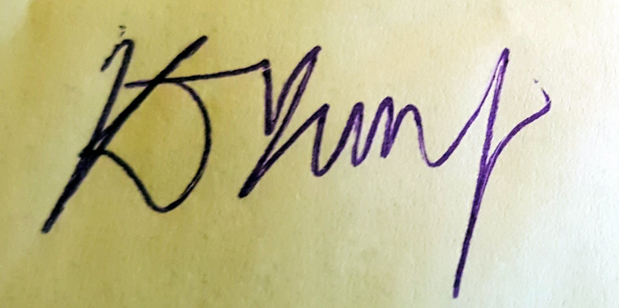
 | Print Name:K J Yusuf
Postal Address (if different from child)

Parents Email Address | kathrynyusuf@gmail.com
Parents Telephone No. | 07947448889
Date: | 12/8/20
I certify that to the best of my knowledge the details in this application are correct. I hereby apply for a licence under section 37 of the Children and Young Persons Act 1963:
Signature of applicant:
(To be signed by person
named on page 1)
Date:

I attach the following:
- A copy of the child’s birth certificate (scanned copies are acceptable – please do not send original hard copies);
- Two identical prints (un-mounted) of a photograph of the child taken during the last 6 months or an electronic likeness (e.g. a jpeg file);
- A copy of the contract, draft contract or other documents (where they exist) containing details of the agreement regulating the child’s participation in the performance or activity to which this application relates.

Notes:
- Electronic versions of this form and electronic documentation are acceptable, including signatures.
- You should ensure that the parent/guardian and the chaperone are given a copy of the whole completed form, which you submit to the local authority.
- Any person who fails to observe any condition subject to which a licence is granted or knowingly or recklessly makes any false statement in or in connection with an application for a licence is liable to a fine not exceeding £1000 (level 3 on the standard scale) or imprisonment for a term not exceeding three months or both (section 40 of the Children and Young Persons Act 1963).

This will only be relevant if the child has moved between authorities in the last 12 months.
By virtue of section 37(3) of the Children and Young Persons Act 1963
As defined within section 3 of the Children Act 1989, ‘parental responsibility’ means all of the rights, duties, powers, responsibilities and authority which by law a parent of a child has in relation to the child and his property.
In the exceptional circumstance where the child’s birth certificate cannot be provided as part of the application (e.g. because they don’t have one) the licensing authority may accept alternative evidence.
The image must not be altered or enhanced in anyway. It should be a full head shot taken in good light.

